12th January 2015

Dear Applicant

I am very pleased that you have requested an application pack for the LSA and SMA role we have coming up. I would love to show you around, so do please ring the school to arrange a visit. The recruitment process is as much about you deciding if our school is right for you as it is us trying to find the right person to fit in with our school and the needs of our children.

We are looking for a member of staff to join our Key Stage 1 team. Even though the member of staff is based in one team they will be working with children from across the school. We have a very strong team at our school and the successful applicant will be given high levels of support to induct them into the role.

Our school is in a relatively deprived area of Hampshire and although our levels of Free School Meals are not high we have around 30% of the school on the Special Needs Register. We have a high turnover of children due to the school being located next to an Army barracks and having 21% of the children from service families. We have a range of children with varying levels of behaviour issues so good behaviour management strategies are essential. As I have said though, you will not be on your own we have a fantastic SENCO and run a variety of Nurture groups to support all children’s needs.

We have high levels of expectation for everyone at the school, children and staff. We all work hard but we have fun while doing it. If you feel that you are still interested in applying for this role please give me a ring and arrange a look around or just to have a chat if you can’t make it in.

I very much look forward to hearing for you.

Matt Greenhalgh
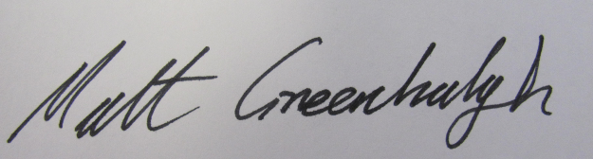

Headteacher

