

Home School Agreement 2018 to 2019

As a school community we agree to follow the school vision and values

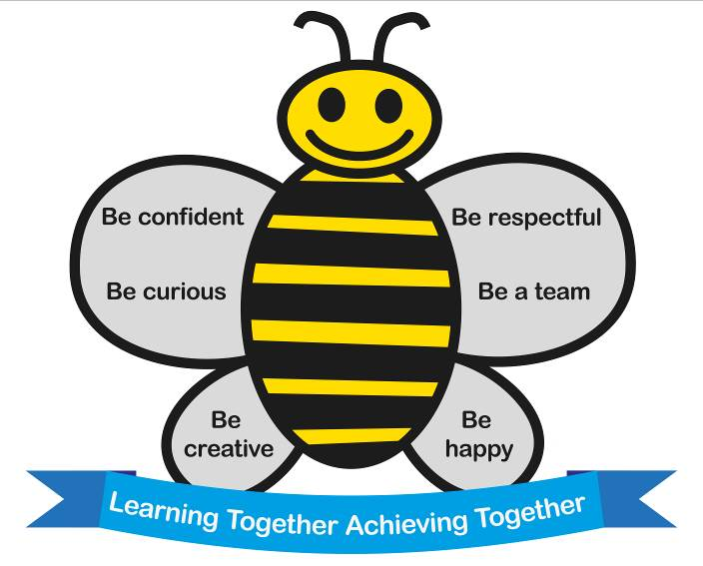

Children
We agree to be the very best learners we can and




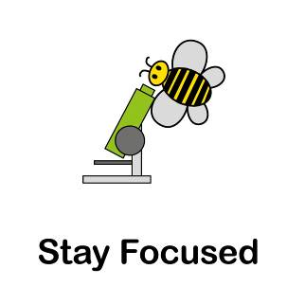


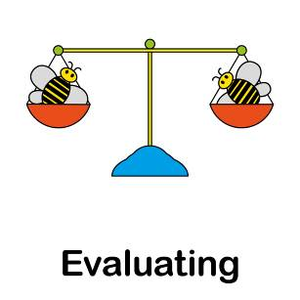


Evaluate
Be Independent
Be a good
communicator

FOR PARENTS AND/OR CARERS, WE AGREE TO:

- Ensure that our child/children arrives at school on time between 8.45 and 8.55am and attends school regularly

- Attend parents’ meetings and talk with the teachers about our child’s/children’s progress

- Read with our child/children at least five times a week and support them with homework such as learning spellings and phonic sounds

- Support the school’s policies on behaviour and work with the school to ensure our child/children hears a consistent message

- Support the school by following the school’s healthy eating guidelines

- Help our child/children to enjoy school by engaging in an open and honest dialogue with the school, trust the school and believe that they have the best interests of our child/children at heart

- Talk to the school directly about any concerns we have and not on social media

- Not put any photographs of our child/children taken in school on social media as they may also have other children in them

FOR ALL SCHOOL STAFF AND GOVERNORS WE PROMISE TO:

- Ensure that we provide a safe, secure and caring learning environment

- Encourage children to do their best to challenge themselves and develop their personalities and talents to the full

- Encourage children to respect themselves, each other, the whole school and the wider community through our school values and a clear consistent approach to behaviour management

- Treat children from all backgrounds equally and give equal access to our curriculum

- Encourage children to lead a healthy life through drinking water, learning about the importance of a balanced diet and being physically active

- Provide a rich and stimulating curriculum of the very highest quality to meet the individual needs of all the children

- Put the needs of each individual child first

