* Jack and the Beanstalk 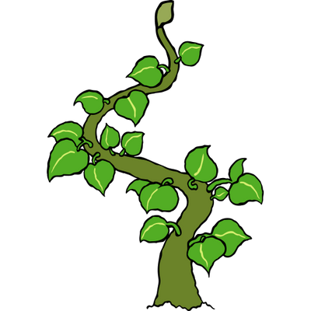

Penguins and Zebras

Topic leaflet Spring Term 2

As we previously mentioned we are including lots of planting in our Jack and the Beanstalk topic. We will be growing our own beanstalks as well as potatoes, strawberries and herbs. Our indoor roleplays will be Garden Centres and we are still looking for donations of old plants, seed packets or tools for these. Additionally if you happen to visit a farm or garden centre over the holidays please share a photo on Tapestry so your child can talk about their visit there.

**Maths**

This term we will be measuring height, weighing, adding and subtracting, doubling and partitioning (breaking down a number).

You can help your child improve their maths by:

* Completing the weekly Maths challenge
* Looking out for numbers in the environment
* Counting to 20 and down from 20 to zero
* Looking at shapes around you
* Asking your child to help with weighing and measuring

**How to help your child at home :**

Don’t forget to read daily, remembering to write in your child’s reading diary so they can progress up the reading rockets and earn these certificates.

Maths homework is sent home every Friday, these are quick, fun challenges that can easily be squeezed into your weekend.

Read write inc homework is sent home each Friday too. In addition to completing this important task, ask them to help you with labels, signs and instructions. Encourage them to write lists for the shopping, birthday cards or ‘to do’ notes.

Help their fine motor skills by asking them to help with the cooking, cut with scissors, use tongs or tweezers and complete jigsaws or other puzzles. Playdough, colouring and painting also boost fine motor skills and in turn help strengthen their handsfor writing.

This half term the children will be focusing on some ‘giant’ books! We will be basing our learning around ‘Jack and the Beanstalk’ but will also be comparing the giant in that story to the very kind ‘Smartest Giant in Town’, additionally we will be reading Jaspers Beanstalk and Silly Jack. We will look at the features of a story such as beginning, middle and end. We will compare the characters in each story and look at their physical features and their personalities.

We will all be having a go at sounding out words we don’t know to make our own sentences and stories. We will continue working hard to get onto the Beehive each week for a special Friday treat.

We will also be introducing helicopter stories into our week. The children love telling a story of their own to a grown up but in addition to this we will be allowing 3 children each week to act out their story with the help of their friends in class. You can find out more about helicopter stories by following this link : https://helicopterstories.co.uk