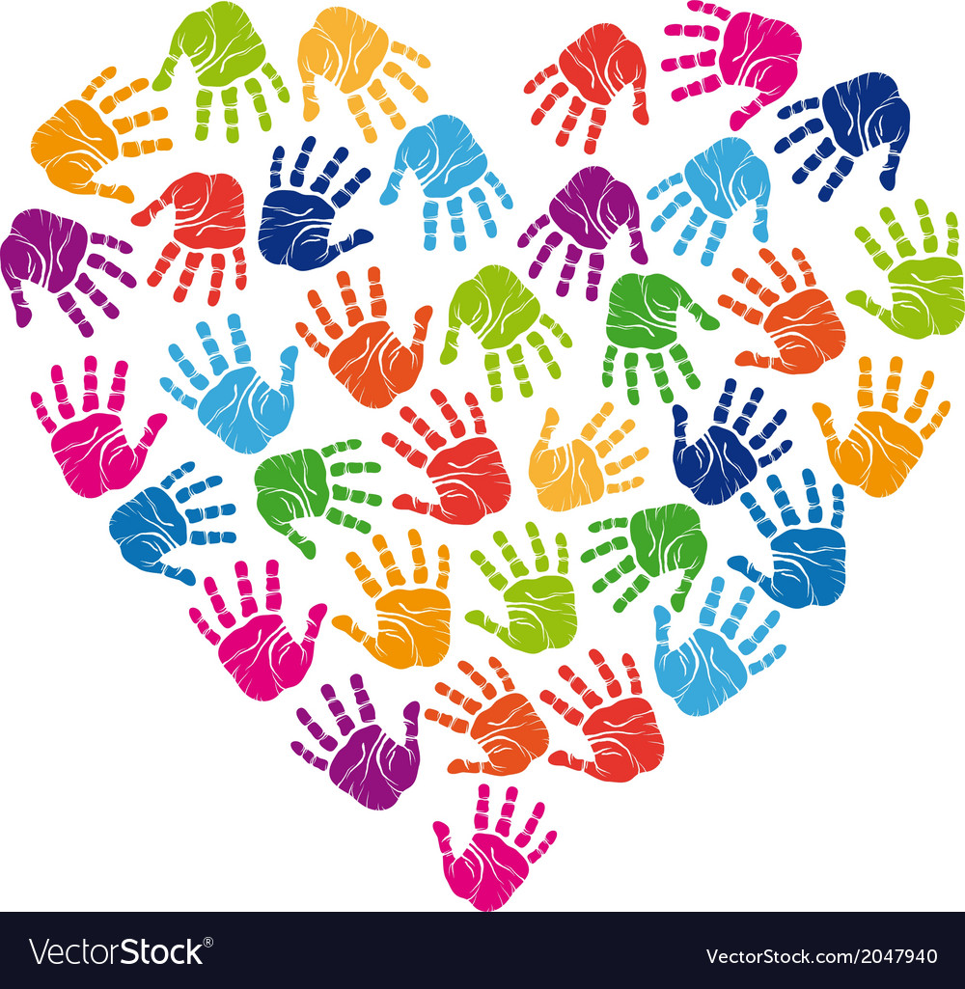

**PSHE at Bordon Infant School**

**Intent**

At Bordon Infant School, PSHE is at the core of what we do and enables our children to become independent, confident, healthy and responsible members of society. Through our whole-school approach to PSHE, it is our belief that excellence in these areas will lead to excellence across the curriculum and beyond in later life. Our PSHE curriculum equips children with relevant and meaningful content, which is supported through a strong emphasis on emotional literacy, building resilience and nurturing mental and physical health. We provide children with appropriate vocabulary to discuss these values and themes. We give our children the opportunity, and support them to have the willingness, to try new things and persevere. We ensure our children have a good understanding of how to stay safe, healthy and develop good relationships and to have an appreciation of what it means to be a positive member of a diverse, multicultural society.

Within PSHE we teach the statutory elements of Relationships and Sex Education (RSE).

**Implementation**

PSHE is taught across the school on a weekly basis alongside developing discussions as topics arise. We follow the PSHE Jigsaw programme, which is carefully planned to build on, and return to, prior learning, skills, knowledge and development over time. Each half term, Jigsaw covers a different topic area as listed below, which includes whole school assemblies to support the themes, imbedding skills at all points of the school day.

• Being Me in My World

• Celebrating Difference

• Dreams and Goals

• Healthy Me

• Relationships

• Changing Me

The mindfulness aspect taught through Jigsaw helps address any emotional health and behaviour issues, which can often create barriers to learning.  Through our teaching of PSHE, children will become aware of their thoughts and feelings as they arise and will be able to focus their mind, transferring these set of skills into their long-term memory and using them to respond to situations appropriately.

Children who need bespoke support may receive this from our Emotional Literacy Support Assistants (ELSAs), gaining extra support to access and benefit from the Jigsaw programme. This can be one-to-one support or small group work.

**Impact**

By the time children leave our school they will have developed all of the key skills and attributes for the next steps in their lives which include a ready willingness and ability to try new things, push themselves and persevere. All children will have a good understanding of how to stay safe, healthy and develop good relationships. It is important that all children have an appreciation of what it means to be a positive member of a diverse, multicultural society. Children are taught to have a strong self-awareness, interlinked with compassion of others.