**Remembrance**



They shall grow not old, as we that are left grow old  
Age shall not weary them, nor the years condemn.  
At the going down of the sun and in the morning  
**We will remember them.**

**Year 2 Autumn 2**

**2023**

**Maths**

This half term the children will be continuing to count in 2’s, 5’s and 10’s using coins, they will then be adding different coins together to make an amount. This will then lead to multiplication and division, the children will be taught how to work out problems on a number line. Please look at our Calculation Policy on the school website for more information on this.

They will also be learning to work out ½, ¼, ¾, and 2/4 of amounts.

At home you could:

* Practise reciting the 2’s, 5’s and 10’s timetables.
* Practise telling the time to o’clock, half past, quarter to and quarter past the hour.

**English**

This half term the children will be writing about a mysterious Silver Box, through this story they will be writing fact files, instructions and then their own story. This will include skills such as question and exclamation marks, using imperative verbs i.e. ‘bossy words’, Go, Stand, Put and using past and present tenses i.e. walked, walk, walking.

At home you could:

* Continue to hear your child read and read books to them above their reading level.
* Continue to practise their weekly spellings.
* Hunt for contractions, look for words that have been combined by an apostrophe i.e. can’t = can + not.
* Look for words in their books that contain the suffix est, ly or er. Discuss with your child how the ending changes the meaning of the word.

**English**

This half term the children will be writing about a mysterious Silver Box, through this story they will be writing fact files, instructions and then their own story. This will include skills such as question and exclamation marks, using imperative verbs and using past and present tenses.

At home you could:

* Continue to hear your child read and read books to them above their reading level.
* Continue to practise their weekly spellings.
* Hunt for contractions, look for words that have been combined by an apostrophe i.e. can’t = can + not.
* Look for words in their books that contain the suffix est, ly or er. Discuss with your child how the ending changes the meaning of the word.

**Religious Education**

The children will be listening to the Jewish story of Passover and discussing what Jews are remembering at this time.

We will then look into how they celebrate this festival and link it to our own experiences and cultures within the classroom.

**History**

We introduce World War 1 through the symbol of the poppy. We look at why the poppy is important and what it represents to people. This then moves onto looking at key events and putting them on a timeline. We visit the Winchester Military Museum where we look at uniforms from World War 1.

**Key words for this subject that the children need to know are:** trenches, World War 1, remembrance, military, chronology.

Remembrance

Military

Chronology

e

Military

Chronology Trenches

World War 1

Remembrance

Military

Chronology

**Design and Technology**

Firstly, the children will be exploring toys that use axles and how they work.

They will then design their own tank with a working fixed axle. Using cardboard boxes and tubes they will hopefully create their own moving tank which they can evaluate at the end of the project.

**Key words for this subject that the children need to know are: free axle, fixed axle, chassis, evaluate.**

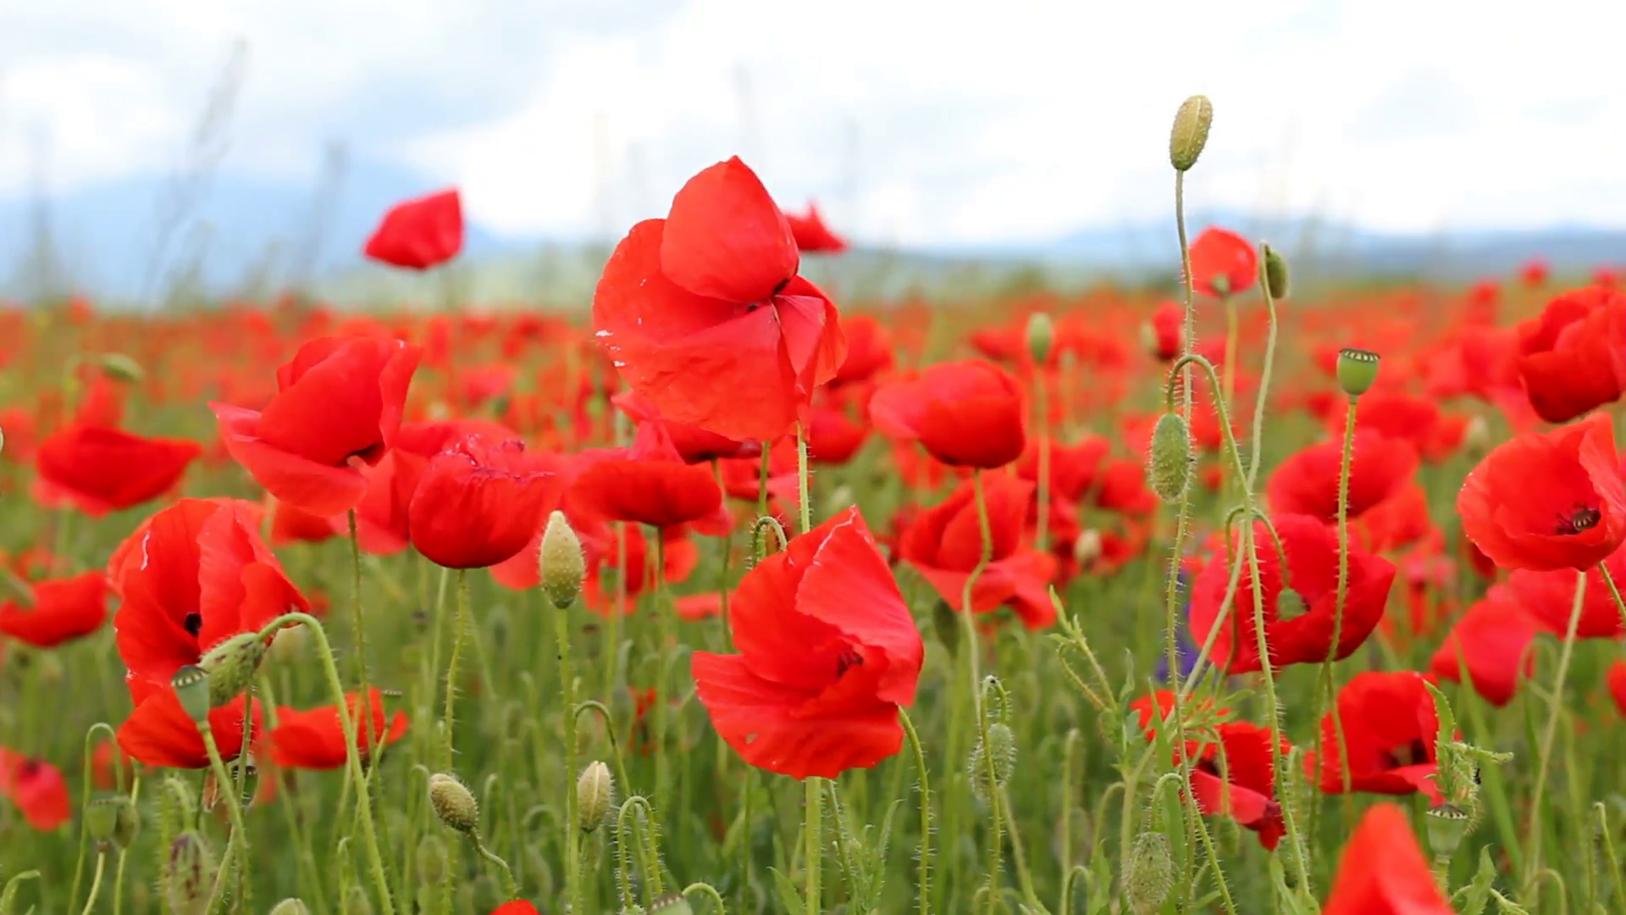

**Parents – Your school needs you too!**

* Please work with your child to research the First World War, in particular, life in the trenches.
* If a family member served in WW1 and you have any photographs or memorabilia, please can you bring it in so we can share it with the children.
* We like to visit the local military cemetery to help support the children’s understanding of remembrance and look at places locally that remind us of people who served in the wars, so we may be asking for helpers for these occasions.
* Calpol boxes and other boxes of a similar size as well as any small junk modelling we would greatly appreciate for our tank making in DT.