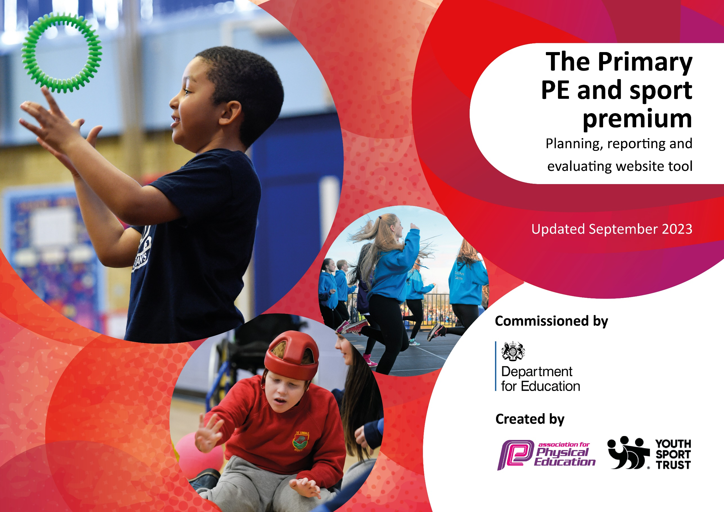

Review of last year’s spend and key achievements (2022/2023)

We recommend you start by reflecting on the impact of current provision and reviewing your previous spend.

Activity/Action | Impact | Comments
- Children to increase the amount of physical activity during the day through excellent playground resources  - Further development of Year R resources to support gross and fine motor skills which develop children’s strength, coordination and fitness  - Sports day will be used as a tool to enhance children’s knowledge of, interest in and engagement with a variety of different skills and knowledge linked to sports with a focus on ‘Olympic Sports’ To promote more active lifestyle and to give children opportunities for activities they cannot get otherwise  - Children to develop good habits and embed an active lifestyle by walking to school daily  - Children know and can play a wide range of playground games, increasing good social communication and interaction skills and further developing active playtimes  - Teachers confidently teach the knowledge and skills needed for the new sporting activities ensuring children’s learning and the development of fundamental skills is excellent | - Children are more active at playtime using the new equipment. Children are trying activities they have not accessed before, such as hoola hooping  - 90% Year R children achieved ELG in physical development  - Children tried new sporting activities for the first time  - The school achieved the Silver certificate of accreditation for parents walking to school  - Children are more engaged at playtime learning new playground games  - PE curriculum enhanced through improved teaching | - Playground resources are low cost but have limited life and need replacing

Key priorities and Planning Total amount £17,187

Action – what are you planning to do | Who does this action impact? | Key indicator to meet | Impacts and how sustainability will be achieved? | Cost linked to the action
- Purchase of new scooters and helmets to go with them | All children | Key indicator 1: The engagement of all pupils in regular physical activity – Chief Medical Officers guidelines recommend that primary school pupils undertake at least 30 minutes of physical activity a day in school  Key indicator 4: Broader experience of a range of sports and activities offered to all pupils | - Scooters will need replacing but will develop children’s enthusiasm and will encourage more family’s to walk or scoot to school. 210 children will benefit this year | £2,000
- Purchase of new balls, batts and other playground equipment |  | Key indicator 1 | - Children to increase the amount of physical activity during the day through excellent playground resources  - Increase | £850
- Employ additional lunchtime supervisors to support enhanced playtime activity and playground games | All children | Key indicator 1 | - Higher participation and engagement in physical activities throughout playtime and lunchtime | £7,000
- Purchase of new family friendly physical development equipment, such as throwing and catching, balls, bats and skipping ropes. Make it sustainable with high quality storage facilities | All children and parents | Key indicator 1  Key indicator 4  Key indicator 2 | - Children to have access to resources before school to promote whole family physical development  - Higher attendance as children and parents want to come to school to engage in activities before school | £2,000
- Provide training for all staff in developing good playground games | All staff and children | Key indicator 3: Increased confidence, knowledge and skills of all staff in teaching PE and sport | - Children know and can play a wide range of playground games, increasing good social communication and interaction skills and further developing active playtimes | £2,000
- Support children and families walking to school through a range of strategies throughout the year, including  - Walk to school week and activities  - Free reflective items for all children promoting safe walking to school  - School to engage with the school travel planning team and all walk to school  - School to produce resources and engage with families | All children and parents | Key indicator 2: The profile of Physical Education, School Sport and Physical Activity (PESSPA) being raised across the school as a tool for whole school improvement | - Children to develop good habits and embed an active lifestyle by walking to school daily  - Improved attendance through developing strong parental habits | £1,000
- To promote and celebrate all sporting achievements that children achieve outside of school | All children | Key indicator 5: Increased participation in competitive sport | - Showing children a range of activities they can take part in  - Promoting a wide range of sports | free
- Continue the development of the dance club afterschool. Two sessions afterschool set up. School to pay for free spaces for children/families identified as benefitting the most for the opportunity/activity | Targeted children | Key indicator 5 | - To promote more active lifestyle and to give children opportunities for activities they cannot get otherwise | £1,680
- Replace the safety surface of bark to ensure that the children can still use the equipment safely | All children |  | - Greater use of the trim trail by the children will develop physical fitness, and strength. It supports balance and coordination development, as well as enhancing children’s wellbeing | £700  Bark will need topping up every 2 years but is still more sustainable financially than any other surface

Key achievements 2023-2024
This template will be completed at the end of the academic year and will showcase the key achievements schools have made with their Primary PE and sport premium spending.

Activity/Action | Impact | Comments

Signed off by:

Head Teacher: | Matt Greenhalgh
Subject Leader or the individual responsible for the Primary PE and sport premium: | Becky Hatchett
Governor:
Date: November 2023

